CHEAT SHEET

Outlook for Packrats: Keeping Your Stuff without Losing Your Mind
Deb Eisloeffel
College of Business Administration
University of Nebraska-Lincoln
Deb.eisloeffel@unl.edu

Tasks
- Go to your Tasks first each day; E-mail Processing is one of many daily items in your routine
Set Tasks as your default folder: File Options Advanced Outlook start and exit
- Drag an email to “Task” (or “Calendar”) link at bottom of screen to copy/convert it to a task

Processing Email
Outlook “Rules”
- Manage emails before they get to your Inbox
- Route messages by: Person/group, to or cc field, keywords in subject or message, date range, etc.
- To do something: move or delete, reply or forward, flag for follow up, create an alert, assign a category, etc.
- Example: Set up a “To Read” folder for e-newsletters, announcements from a professional organization, or emails from your aunt who sends you weekly crock pot recipes. Automatically route for reading later.
- Find Rules at Home tab Rules button Manage Rules and Alerts click “New Rules” for wizard

Quick Steps
- Use Quick Steps to enact rules for assigning categories or moving to folders
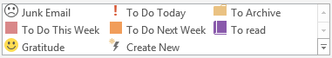

- Set up and Manage Quick Steps at Home tab Ribbon

Additional Tips for Processing
- Use “Find related” emails
R click Find Related Messages in this conversation, Categorize all
  - Manage in a batch
  - So you don’t answer already resolved issues
- You can edit emails sent to you by another
Open email, Message tab Actions edit message
- Searches – Customize your Quick Search fields
Click in Search Field. On Search Tools tab, select More select desired fields (your fields will now come up each time you click the Search Field)

Categories
Assign a Category
- Right click while hovering over category field OR go to Category button on Ribbon
- Drop-down menu shows the last 15 categories used
- Open All Categories Dialogue Box
  - If using a non-recent Category
  - If assigning more than one Category
  - If creating a new Category

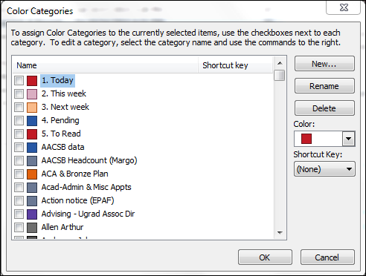
All Categories Dialogue Box

- Select “All Categories” and type first 3-letters to “find” the one you want. Click to select, click “Okay”
- Make new Categories or rename as needed
- Use colors to further categorize, if desired

Resources

Getting Things Done: The Art of Stress-Free Productivity, David Allen
See also his TEDx talk: https://youtu.be/CHxhjDPKfbY or search GTD on Google or YouTube

Maximize Your Productivity with Outlook 2010-13 Part 1 Email Management, Surface7Associates
https://www.youtube.com/watch?v=EE6E5WX5AJM

2:08 Having NO system causes stress  2:49 How I manage my E-mail  4:56 Creating folders to organize E-mail  6:25 Creating categories in E-mail  7:50 Creating & applying Quick Steps  12:25 Scheduling action categories  13:13 Customize Outlook's Start folder | 14:00 Summary pt 1  15:00 Stay focused, minimize distractions  16:04 The 4 D's Model  19:02 You make the RULES  20:12 Creating RULES  23:45 Summary pt 2

Maximize Your Productivity with Outlook 2010 Part 2 - Managing Tasks, Surface7Associates
https://youtu.be/GJJu4dAbiso

1:39 Cleaning your Task list view  2:33 Outlook's To-Do bar  3:31 Viewing Tasks alongside Appointments  4:19 Viewing all Tasks | 5:10 Sorting Tasks  7:30 Assigning Tasks to others  8:59 Create a To-Do item from a contact  9:45 Summary

Outlook for Packrats
Presentation PowerPoint - http://bit.ly/1LAYI3U
Cheat Sheet - http://bit.ly/1W2pGpQ

